Azure API Management
https://www.youtube.com/watch?v=xtcFhePsxNg

Management layer
- Accepts API calls and routes them to your backends
- Verifies API keys , JWT tokens , certificates and other credentials
- Enforces usage quotas and rate limits
- Transforms your API on the fly without code modifications
- Caches backend responses where set up
- Logs call metadata for analytics purposes

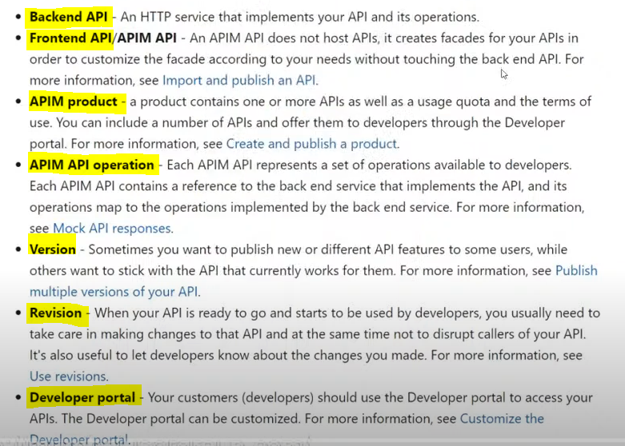

We can add a Logic App , App Service , Function App at the backend along with the API at the Azure API Management

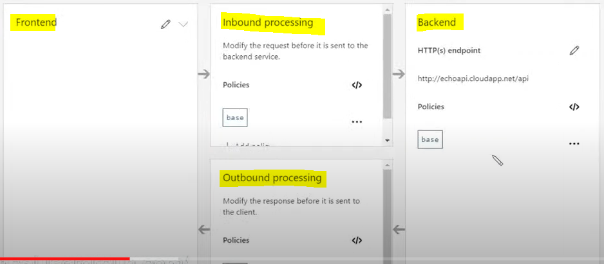

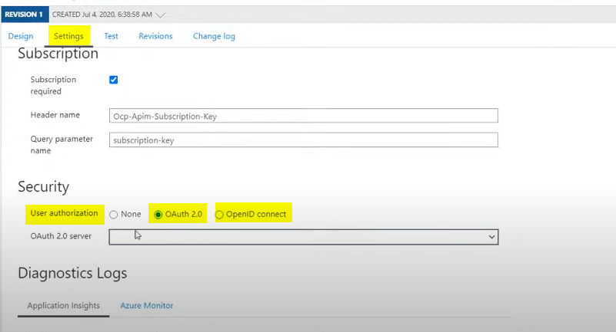

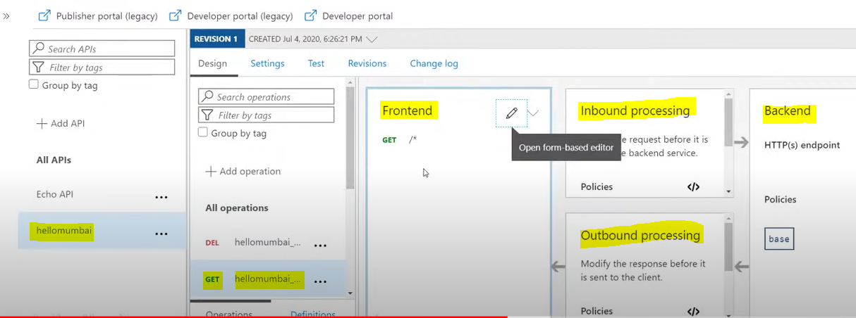

Front end and back end API

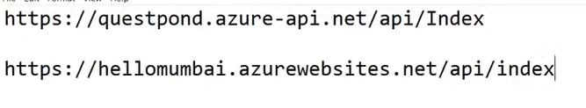
Add revision and inbound policy

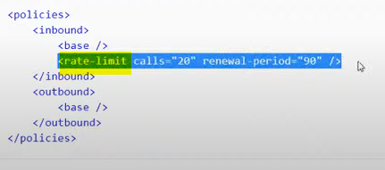

Two versions , added limit to a new version

